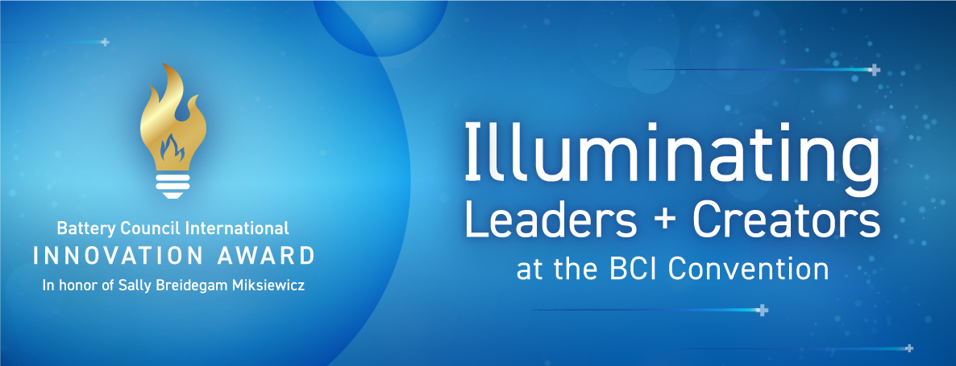

2026 BCI Innovation Award Submission Form
Thank you for your interest in the annual BCI Innovation Award! The annual award was created in honor of Sally Breidegam Miksiewicz and recognizes innovations within the battery industry that align with the guidelines of sustainability, safety, cost, performance, uniqueness and value.
Every year, hundreds of innovations occur within the battery industry – from packaging and technology to equipment, chemistry and beyond. The goal of the BCI Innovation Award is to collect all of these innovations and showcase them to both the industry and the public.

Contact information and submission details
To make the submission process as simple as possible, BCI will work directly with you to obtain all files in whatever form works best for your organization.
To begin your submission process, simply fill out this Word document then email it to Katie Raymond at kraymond@batterycouncil.org and Jeff Reeves at jreeves@batterycouncil.org. We will then work with you directly to ensure your relevant supporting files and documents are received. BCI accommodates Dropbox, Sharepoint, WeTransfer, and a host of other file sharing services. Just let us know what you prefer.
In addition to any supporting documents, BCI asks that all entrants submit a high-resolution video that is no longer than 75 seconds. All entrants will see their video screened as part of the BCI Convetnion + Power Mart Expo on the main stage, before the Innovation Award winner is announced to all attendees.

Submission details
Please fill out the following form with as much information as possible to help our judges make their selection. Entries do not need to align with all guidelines, and are open to all battery chemistries and products. You do not have to be a member of Battery Council International to submit an entry for the 2026 Innovation Award.
Providing multiple supporting documents that align with these guidelines will give judges additional insight and clarity on your submission.
- Sustainability – How does your submission show environmental stewardship? Provide tangible aspirations, goals and objectives in helping to create a greener tomorrow.
- Safety – Does your submission show product and/or process stability? Can it be safely commercialized? Demonstrate a clear commitment to the safety of the general public and industry.
- Cost – Can the submission be easily commercialized and/or provide cost-optimized advantages? Is it an affordable alternative to existing technologies and processes?
- Performance – Show how your innovation meets its intended key objectives, goals and benefits.
- Uniqueness – How does it differ from existing products? Information should clearly define what makes this product, process and/or discovery unique.
- Value – How does the submission directly benefit the battery industry? Can the product be utilized outside of the company that created it?
If you have any questions about the process, please contact BCI’s Katie Raymond at kraymond@batterycouncil.org and Jeff Reeves at jreeves@batterycouncil.org.

